**IIOT Assignment-10**

1. Interface Two DC motors with Arduino , one should move in forward direction and other will move in reverse direction simultaneously.

Ans :

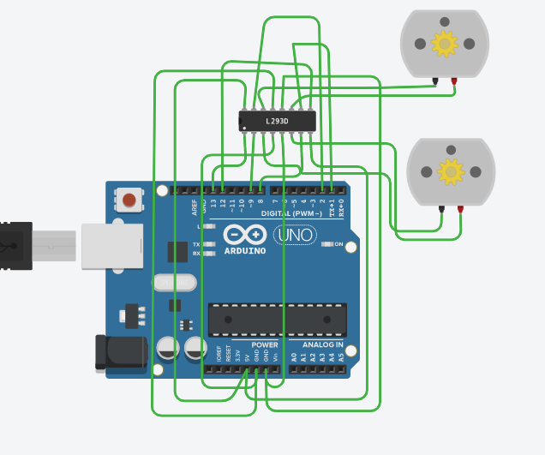

void setup()

{

pinMode(13, OUTPUT);

pinMode(8, OUTPUT);

pinMode(9, OUTPUT);

pinMode(12, OUTPUT);

pinMode(1, OUTPUT);

pinMode(2, OUTPUT);

digitalWrite(13, HIGH);//set this pin to HIGH to enable motor-1driver

digitalWrite(12, HIGH);// set this pin to HIGH to enable motor-2 driver

}

void loop()

{

digitalWrite(8, HIGH);

digitalWrite(9, LOW);

delay(200);

digitalWrite(1, LOW);

digitalWrite(2, HIGH);

}

1. Explain the characteristics and applications of RFID in various fields?

Ans : RFID is stand for Radio Frequency Identification

The use of radio frequency tags to identify real objects.

RFID (Radio Frequency Identification) is a technology used for electronic and wireless identification of objects, humans and animals

An ADC (Automated Data Collection) technology that:uses radio-frequency waves to transfer data between a reader and a movable item to identify, categorize, track.

It consists of 2 components (in case of a passive tag). They are Microchip and an antenna. You can know more about RIFD Tags here.

Microchip: It is a semiconductor device which consists of a circuit etched in it with some KB of memory storage, capable of storing data and transmitting it whenever needed.

Antenna: It is used to transmit the data that is present in the chip into air so that it can be detected by a reader.

Incase of an active tag it consists of Microchip, battery and an antenna

Battery: In active devices in order to power up the microchip battery is externally used.

**Applications of RFID**

❑Used in office/schools for attendance management.

❑Used for inventory tracking.

❑Used to avoid fraudulent/stolen products from malls and super markets.

❑In constructions industries RFID technology can be used to manage materials.

❑Used in Real Time Location systems (RTLS) for tracking the location of a particular asset or an employee.

❑Used to lock and unlock the doors.

1. Explain the working of RFID?

Ans: Working of RFID

* An RFID system consists of two main components, a transponder or a tag which is located on the object that we want to be identified, and a transceiver or a reader.
* The RFID reader consist of a radio frequency module, a control unit and an antenna coil which generates high frequency electromagnetic field.
* On the other hand, the tag is usually a passive component, which consist of just an antenna and an electronic microchip, so when it gets near the electromagnetic field of the transceiver, due to induction, a voltage is generated in its antenna coil and this voltage serves as power for the microchip.
* Now as the tag is powered it can extract the transmitted message from the reader, and for sending message back to the reader, it uses a technique called load manipulation.
* Switching on and off a load at the antenna of the tag will affect the power consumption of the reader’s antenna which can be measured as voltage drop.
* This changes in the voltage will be captured as ones and zeros and that’s the way the data is transferred from the tag to the reader.